San Mateo-Foster City School District
Cell Phone Free Environment
Middle School Student Policy Contract
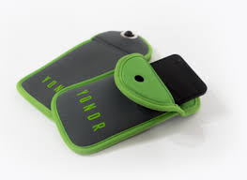
https://www.overyondr.com/

The San MateoFoster City School District aims to maximize every student’s opportunity to learn and build positive relationships at school. The 2022-2023 school year will be a cell phone-free learning environment at the Middle School level. We have found that cell phone use on campus has resulted in significant distraction to the academic environment. We have also found that online bullying takes place at an accelerated rate due to student cell phone use on campus.

Each middle school student will receive a Yondr Pouch (shown above) that will allow students to safely store their cell phone during the school day. Our students will be able to disconnect from their phones and engage more meaningfully with peers and staff. Each student will adhere to the following guidelines and procedures:

- I understand that my phone must be turned off and inside my Yondr pouch upon entering my first class each day of school and will remain in the pouch until the end of the school day.

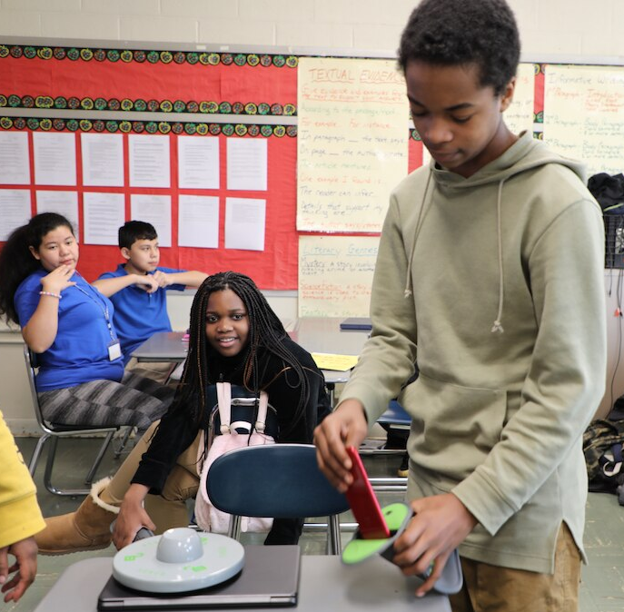
- I understand that I will not try to open the Yondr pouch during the school day without consent from a SMFCSD staff member.

- I understand that I should remain in possession of my locked pouch at all times and that the SMFCSD is not responsible for lost or damaged phones.

- I understand that phones found outside the pouch during the school day will be confiscated by the school administration and that a parent/guardian will have to pick it up at the school office.

- I understand that I will be allowed to demagnetize the pouch and access my cell phone as I exit campus at the end of the school day.

- I understand that if there is an emergency, I can go to the office to use a phone with permission from a staff member.

- I understand that if I struggle to follow the outlined guidelines as listed above, the school administration may reach out to parents/guardians to confere, review the contract, and problem-solve.

- I understand that if I damage or lose my pouch, I may be responsible for purchasing a replacement pouch for $20.00 (or will work with the school site administrator to acquire a replacement pouch to the best of my ability).

By signing this contract, I understand all the terms and conditions listed above. This contract is to be reviewed by students and parents/guardians, signed, and returned to the school site.

Student Name:_________________________________________Grade:____________

Student Signature:_______________________________________________________

Parent/Guardian Name:___________________________________________________

Parent/Guardian Signature:________________________________________________

*************************************************************************************************************

If your student will not be bringing a cell phone to school, please sign here. Your student will still be issued a Yondr pouch and will be expected to keep the pouch in their possession. If your student decides to bring a cell phone to school they will be required to use their Yondr pouch.

Parent/Guardian Name:______________________________________________________

Parent/Guardian Signature:___________________________________________________

_________Please initial here if your student has a documented medical condition that requires the use of a cell phone during the day. If this is the case, an administrator will contact you to discuss.

